1.1 STM32F103C8T6 Deep Orientation
We already covered the identity and hierarchy. Now let's map the actual MCU architecture.
1. STM32F103C8T6 at a glance
Think of the MCU as:
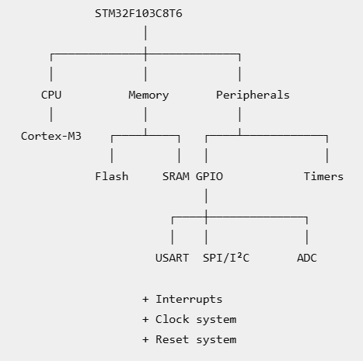
This is the mental map I want you to carry into the rest of the course.

2. CPU: Cortex-M3
The CPU inside the STM32F103 is an ARM Cortex-M3 core.
It is responsible for:
Fetch instruction
↓
Decode instruction
↓
Execute instruction
↓
Read/write memory or peripherals
It contains the programmer's model we studied in Level 0:
R0-R12
SP
LR
PC
xPSR
So when your C program runs:
int x = 10;
x++;
the Cortex-M3 is ultimately executing machine instructions that manipulate registers and memory.

3. Flash
The STM32F103C8T6 has internal Flash memory used primarily for your program and nonvolatile data.
Conceptually:
Flash
├── Vector table
├── Program instructions
├── Constants
└── Other read-only/program data
When you build your CubeIDE project and program the MCU, your firmware is stored in Flash.
That's why after power is removed, your program doesn't simply disappear.

4. SRAM
SRAM is the MCU's runtime working memory.
During execution you'll encounter things such as:
SRAM
├── Global/static variables
├── Local variables
├── Stack
└── Possibly heap
For example:
int counter = 0;

int main(void)
{
int x = 10;
}
The variables and runtime state require RAM according to their storage duration and placement.
And remember our Level 0 startup discussion:
Reset
↓
Startup code
↓
.data / .bss setup
↓
main()
So the memory model is already connected to the actual startup process.

5. GPIO
GPIO means General-Purpose Input/Output.
These are the pins through which the MCU interacts with external digital hardware.
Conceptually:
STM32
│
├── GPIOA
├── GPIOB
├── GPIOC
├── GPIOD
└── GPIOE
A GPIO pin can potentially be configured for functions such as:
Digital input
Digital output
Alternate function
Analog
Depending on the specific pin and device capabilities.
For example, instead of thinking:
"PA5 is just a physical pin."
think:
PA5
↓
GPIO port/pin
↓
GPIO peripheral
↓
GPIO registers
↓
physical MCU pin
We'll go deep into these registers in Level 2, so we're deliberately stopping here.

6. Timers
The STM32F103 contains hardware timers.
A timer is hardware that can count according to a clock.
Conceptually:
Clock
↓
Prescaler
↓
Counter
↓
Timer event
Timers can support things such as:
- time measurement
- periodic events
- interrupts
- output compare
- input capture
- PWM
We'll properly study these in Level 3.
For now, the important point is:
A timer is hardware inside the MCU, not something your CPU has to manually count every cycle.

7. Communication peripherals
The STM32F103 contains hardware communication peripherals such as:
USART
SPI
I²C
Instead of manually toggling GPIO pins to implement every communication protocol, dedicated peripheral hardware handles much of the protocol operation.
For example:
CPU
↓
configure USART
↓
USART hardware
↓
TX pin
We'll study each protocol in Level 4.

8. ADC
ADC means:
Analog-to-Digital Converter
This lets the MCU convert an analog electrical quantity into a digital value that software can process.
Conceptually:
Analog voltage
↓
ADC
↓
Digital number
↓
CPU/software
This becomes very relevant to your sensor work later.
For example, an analog sensor might produce a voltage corresponding to some physical quantity.
Again, we're only establishing its place in the architecture now. Detailed ADC operation comes in Level 4.

9. Interrupt system
We've already studied interrupts conceptually.
Inside the STM32, an event can cause an interrupt request:
Peripheral/event
↓
Interrupt request
↓
NVIC
↓
CPU
↓
ISR
Examples include:
Timer event
GPIO external interrupt
USART event
ADC event
The Cortex-M3's interrupt controller is the NVIC, the Nested Vectored Interrupt Controller.
Detailed implementation comes in Level 3.

10. Clock system
Every synchronous digital system needs timing.
The STM32F103 has a clock system involving sources such as:
HSI
HSE
LSI
LSE
PLL
At a simplified level:
Clock source
↓
Clock selection / PLL
↓
SYSCLK
↓
AHB / APB
↓
Peripheral clocks
The clock system determines how fast various parts of the MCU operate.
But remember the distinction we learned in Level 0:
Clock frequency and peripheral clock enable are different things.
We'll revisit the actual RCC registers when the relevant peripherals are introduced.

11. Reset system
Reset puts the MCU or a peripheral into a defined starting state.
At the MCU level:
Reset
↓
initial CPU state
↓
vector table
↓
Reset_Handler
↓
startup
↓
main()
Individual peripheral reset mechanisms also exist within the RCC system.
So:
Clock → allows operation
Reset → establishes initial state
Don't mix those two.

12. Programming and debugging interface
This is the part we hadn't properly covered.
For professional STM32 development, programming and debugging are related but distinct activities.
A common STM32 debug/programming interface is:
SWD, Serial Wire Debug
It allows a compatible debugger/programmer, such as an ST-LINK, to communicate with the MCU.
Conceptually:
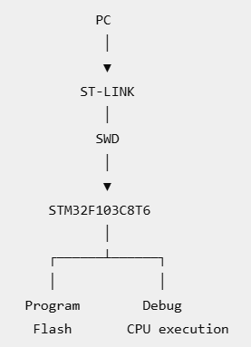
Programming
Put firmware into Flash.
Debugging
Interact with the running MCU to investigate execution.
For example:
Breakpoint
↓
CPU stops
↓
Inspect variables/registers
↓
Step through instructions
This distinction will become important when we start using CubeIDE's debugger.

13. Now map everything together
This is the part I want you to remember.
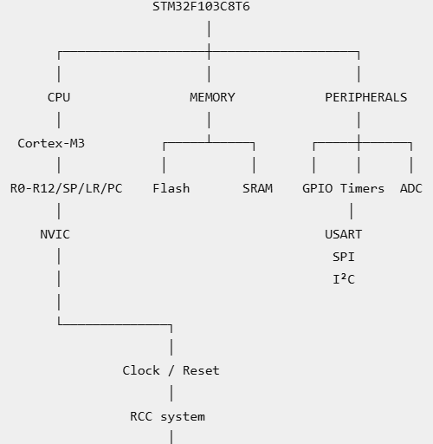
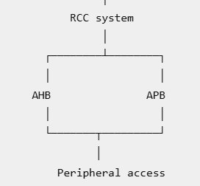

And externally:
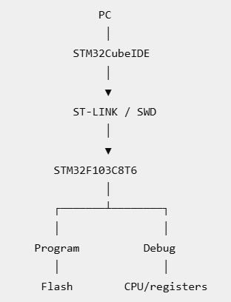
🧪 1.1 Final checkpoint
Keep this short.
Q1
What is the difference between these three?
Cortex-M3
STM32F103C8T6
Blue Pill
Q2
A temperature sensor produces an analog voltage. Which major block inside the STM32 would convert that voltage into a digital value?
Q3
What is the difference between programming the STM32 and debugging the STM32?

Answers:
1. M3 is processor/cpu, that is mcu , blue pill is development board
2. ADC (Analog to digital convertor)
3. programming is writing firmware into flash and debugging is interacting with mcu while executing our program
Correct. 3/3. ✅
One small precision on Q1:
Cortex-M3 = CPU core/processor architecture
STM32F103C8T6 = complete MCU containing that Cortex-M3 core + memory + peripherals + clock/reset systems
Blue Pill = development board built around the STM32F103C8T6 MCU
So don't say "M3 is the MCU." The M3 is the CPU core inside the MCU.
Your Q2 and Q3 are exactly right.
✅ Level 1.1 COMPLETE
You've now covered the entire 1.1 syllabus:
- STM32F103 family ✅
- STM32F103C8T6 ✅
- Cortex-M3 relationship ✅
- MCU vs development board ✅
- Blue Pill architecture ✅
- CPU ✅
- Flash/SRAM ✅
- GPIO ✅
- Timers ✅
- Communication peripherals ✅
- ADC ✅
- Interrupts ✅
- Clock/reset ✅
- Programming/debugging interfaces ✅
- Architecture mapping ✅

Next: 1.2 STM32 Memory & Device Organization
Here we'll make one important transition:
Level 0:
"Flash, SRAM and memory-mapped peripherals exist."
Level 1.2:
"Where exactly are they in the STM32F103 memory map, and how does the CPU see them?"
We'll use the actual STM32F103 memory organization and connect it to CubeIDE + the linker + your program.

